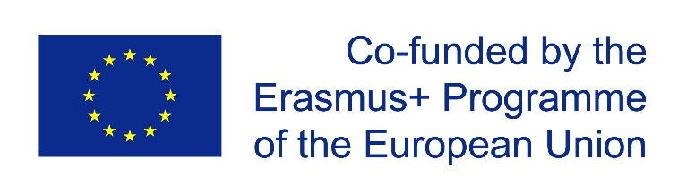

NTU KhPI MASTIS team
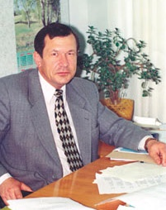 | Mykhailo GODLEVSKYI,  National Technical University ‘Kharkiv Polytechnic Institute’, (Ukraine),  Professor, Dr of techn. Science,  Head of Software Engineering and Management Information Technologies Department,  Member of Ukrainian National Methodical Commission in Computer Science  Member of Council of Experts of State Accreditation Commission in Computer Science  Member of the Academy of Science of Higher School in Informatics and Applied Mathematics | god_asu@kpi.kharkov.ua | Mobile phone:  +380(67) 7317207  +380(50) 3024377  Skype:
 | Olga CHEREDNICHENKO  National Technical University ‘Kharkiv Polytechnic Institute’, (Ukraine),  PhD, Associate Professor of Software Engineering and Management Information Technologies Department | olha.cherednichenko@gmail.com | Mobile phone:  +380(67)7547944  +380(99)9277830  Skype:  marxx.olga
 | Volodymyr SOKOL  National Technical University ‘Kharkiv Polytechnic Institute’, (Ukraine),  Doctor of technical science (Austria, equivalent of PhD),  Associate Professor of Software Engineering and Managemen tInformation Technologies Department | vlad.sokol@gmail.com | Mobile phone:  +380(96)4916961  Skype: vladsokol
 | Tetiana ZAKHAROVA,  National Technical University ‘Kharkiv Polytechnic Institute’, (Ukraine),  PhD, Associate Professor of Software Engineering and Management Information Technologies Department | tetiana.zakharova@gmail.com | Mobile phone:  +380(50)5684816  Skype:  zakharova_tatyana
 | Olga KANISHCHEVA,  National Technical University ‘Kharkiv Polytechnic Institute’, (Ukraine),  PhD, Associate Professor of Intelligence Computer Systems Department | kanichshevaolga@gmail.com | Mobile phone:  +380(66)6818498  Skype:  olya-kanisheva
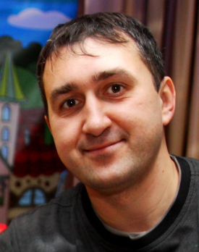 | Sergii ORIEKHOV,  National Technical University ‘Kharkiv Polytechnic Institute’, (Ukraine),  PhD, Associate Professor of Software Engineering and Management Information Technologies Department | sergey.v.orekhov@gmail.com | Mobile phone:  +380(98)4806072  Skype:  sergey_orekhov_2005
 | Olha YANHOLENKO,  National Technical University ‘Kharkiv Polytechnic Institute’, (Ukraine),  PhD, Assistant of Software Engineering and Management Information Technologies Department | olga.yan26@gmail.com | Mobile phone:  +380(98)4381114
 | Anna GOLOSKOKOVA,  National Technical University ‘Kharkiv Polytechnic Institute’,  Assistant of Software Engineering and Management Information Technologies Department | khpi.goloskokova@gmail.com | Mobile phone:  +380(93)1235090  Skype:  anna_goloskokova
 | Daria KHRIPUNOVA  National Technical University ‘Kharkiv Polytechnic Institute’  Engineer of International Relations Department | khripunova.daria@gmail.com | Mobile phone:  +380(66)3447551

