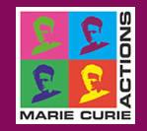

REGISTRATION FORM

“Opportunities for Ukraine participation in Marie Curie Actions”

Date: 19-20 May 2011

Venue: State Agency on Science, Innovation and Information of Ukraine,
Boulevard Shevchenko 16, Kyiv, Ukraine

Dear colleges! You are kindly asked to fill the following Registration form in and send it by e-mail to ic@fp7-ncp.kiev.ua till 6 May 2011!

Your name and surname

Your organization

Your position

Your e-mail

Did you participate in any Mary Curie Activity before? If Yes, what kind of activity?

